Senior Services Study Executive Summary

City of Casper
Community Builders, Inc.
April 2016

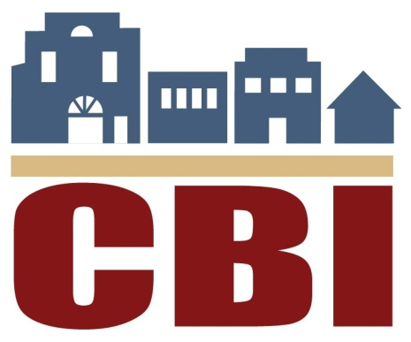
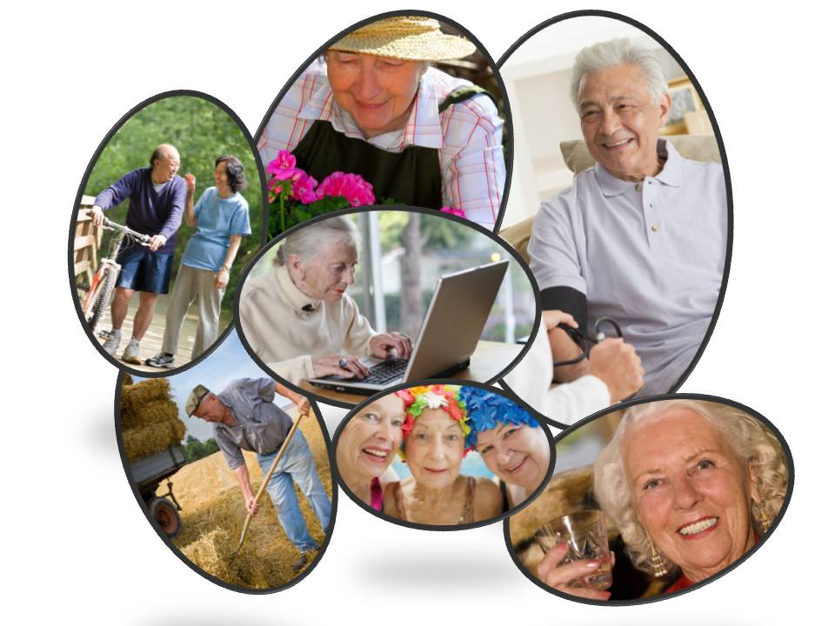
Working to make Casper a livable community for people of all ages.
Senior Services Study Update 2016 Executive Summary and Talking Points

The City of Casper contracted with Community Builders, Inc. (CBI) in July 2015 to update the 2008 Casper Baby Boomers: A Community-Based Action Research Project for Community Services for Older Adults. Key progress has been made from that report's recommendations.

- Purpose of 2016 Senior Services Study Update - need to anticipate future trends and adapt to these changing demographics.

- Process
  - Needs assessment survey of 32 area agencies providing services to senior population
  - Written and/or online community survey targeting those 50+ -- 420 received
      - Three main areas of concern with regard to unmet needs for the seniors - transportation, mental healthcare, and in-home services.
  - Comparison to objective demographics
  - From 2010 to 2040, population of Natrona County is forecast to grow by nearly 40%, however population of local residents 65 or older expected to reach 19,438 residents (107% growth).
  - Median age - 36.2 years old
  - 1/3 of households are home to 60+ resident; 4,000 of those live alone
  - Unemployment rate for 60+ is much lower than general population
  - People 65+ slightly more likely to be living in poverty in Natrona County (6.7%) than elsewhere in Wyoming (6.3%).
  - Created inventory of service providers in community serving those aged 50+
  - Conducted literature review

- Boomer Generation trends
  - Smaller numbers of family and friends for support systems
  - Financial-stability needs lead them to retire later or not at all
  - Want to travel and stay fit and healthy

- Study Committee met monthly and held targeted-listening sessions on identified themes

- Developed Recommendations in each thematic area categorized by level of priority
- Level I: Options which could be implemented immediately with little or no cost.
- Level II: Options which will require investments of time and resources to be fulfilled.
- Level III: Long-term options requiring commitment of staff-time and significant resources on the part of one or more agencies.

Summary recommendations in each area follow.
Community Design - accessible, walkable community design; zoning code updates

Recommendations
- GIS mapping education on transitional curb cut locations
- Create Advisory Committee on community design to help evaluate community for accessibility
- Zoning Code updates to permit senior housing options such as zero lot lines, RV parking, smaller lots, etc.
- Walkable neighborhood design to construct senior apartments near retail centers
- Continued development of walkways/sidewalks to enable connectivity and promote walkability and good health
- Support sidewalk-replacement funding-assistance for damaged sidewalk areas
- Promote or require the parkway-development style in new subdivisions where greenspace is required between sidewalks and curb and gutters
- Become part of the AARP “Livable Communities” Program

Transportation - availability of adequate and affordable public or private transportation.

Recommendations
- Opportunity to expand faith-based organization transportation programs
- Transit Development Route Study to evaluate need for more flexible schedules, fixed stops and extended hours for CATC and The Bus
- Expand existing taxi voucher program
- Explore grants that would assist in the purchase of an accessible van
- Support efforts to form volunteer community service organization that provides transportation for seniors

Financial - financial transition issues facing the Boomer Generation, including retirement planning, Medicare counseling services, bank support, and events that could help seniors navigate the programs available to them.

Recommendations
- Additional programs for Medicare/Medicaid information and counseling services
- Encourage local banks to assist older patrons in learning about topics affecting them
- Media campaign to highlight positive financial contributions that exist when retirees remain in the community (the “Longevity Economy”)
- Provide tips and suggestions on making existing businesses more age-friendly
- Host a “Successful Aging Expo” in Casper focusing on the needs of the aging population
- Work with the Central Wyoming Senior Services to expand their annual Senior Fair
- Create a senior-information directory containing information on services and programs that are available to meet the needs of seniors
- Encourage modification of the Wyoming Department of Health Federal ADRC (Adult Disabled Resource Center) to create an online hub for Casper-area resources
Healthcare - discussion of public-health services; home-health care options; mental health needs; life-sustaining treatment options; and educational services to assist seniors in understanding their healthcare options.

Recommendations
- Promote private, in-home mental health counseling and care services
- Promote utilization of POLST (Provider Orders for Life-Sustaining Treatment) by providers and families to ensure that consistent directives are in place
- Support licensed hospice respite care services
- Coordination of Care improvements to improve outcomes of patients discharged from hospital
- Rural Care Transitions Program: Discuss PACE (Program of All-Inclusive Care for the Elderly), Rural Care Transitions Program, as well as telemedicine programs and its connectivity to the mental health community
- Promote Wyoming 2-1-1 to seniors - information about critical health and human services available in Wyoming communities
- Monitor and evaluate healthcare from the patient's perspective
- Develop training programs for front-line employees, first responders, and others on how to effectively interact with people who suffer from other age-related conditions
- Develop training programs for geriatric social workers and/or nurses which include involvement from local nursing homes
- Evaluate needs for a geriatric-assessment unit to be established at one of the hospitals or through some other provider
- Evaluate the need and ability to provide dedicated space to serve chronic mental health patients
- Work with the State of Wyoming to determine if it may be possible to open a branch office for Medicaid services in Casper on a regular basis
- Work with the Casper Fire Department to develop Community and Public Health Program under Community Response Team Model established by Colorado Springs Fire Department
- Facilitate a task force to work with Wyoming Medical Center (WMC) or other hospital to develop the PACE Program (Program of All-Inclusive Care for the Elderly) in Casper
- Identify funding for a program to provide individual counseling services to seniors needing assistance dealing with the various problems related to aging

Housing - support the growing population of seniors who wish to remain in the community and who have desire to remain in their own homes. Single-level, single-family homes that meet the needs of an increasingly disabled resident are difficult to find.

Recommendations
- Work with the WCDA Tax Credit Program to encourage the funding of a project in Casper that would be dedicated to residents age 55 and over
- Facilitate meeting of the assisted living industry, nursing homes, and the Wyoming Department of Health to discuss potential changes in the regulations for transitioning residents from assisted living to nursing home environments
- Encourage the City to adopt a requirement that new home construction include a recommendation (not a requirement) for Universal Design Standards which call for one bedroom, one bathroom, and the cooking area be designed to be accessible for someone with physical restrictions
- Identify concepts that are needed to support housing developments designed for seniors.
- Host workshop for seniors and developers to examine additional options for housing units that may require amendments to codes or changes in financial packages to move forward. Examples include equity exchange; cluster homes, granny flats
- Develop program to provide assistance to seniors for services that would address needed improvements and repairs to individual homes
- Work with developers to conduct a market study of demand and need for new housing options that would appeal to seniors

Lifelong Learning, Social and Civic Engagement, and Recreation - Providing and promoting a variety of leisure activities that develop and enhance social-networking opportunities.

Recommendations
- Develop comprehensive inventory of resources to include active and passive recreation and fitness options, facility descriptions, transportation access, organized trips, tours and cruises, and venues to pursue lifelong learning
- Support a “Community Reads” program where books are provided, read, and discussed by participants of all ages
- Host a program on preparing individual histories or utilizing seniors to learn more about their connection to the history of Casper
- Collaborate with the Small Business Administration (SBA) on development of a local SCORE program
- Assist in recruiting instructors for basic classes on technology for seniors, including courses on basic computer and internet skills
- Work with local museums on a passport program for seniors which would include an incentive for seniors to visit all of the local museums, historic sites, parks, etc., during the summer months
- Host a meeting with representatives from Central Wyoming Senior Services, the Wyoming Department of Health’s Aging Division, local government, and state legislators to discuss how to enhance the funding model for senior centers to support operations beyond the meal-based model which is currently used by the Federal/State Agencies on Aging
- Encourage support of the Casper YMCA on their capital investment in new facilities which will continue to serve the senior population in the center of the community
- Continue to support construction of new trails and improved accessibility of existing trails throughout the community

Workforce/Employment and Volunteer Opportunities - Utilize retirees in the workforce in meaningful and gainful ways.

Recommendations
- Revisit demographics on Boomers turning 65 and evaluate possible impacts on the workforce in public and private sectors of the economy
- Increase awareness of volunteer opportunities and how to get involved
- Work with the Department of Workforce Services (DWS) to develop a skills-bank database and jobs clearinghouse that connects older workers with employers for needed job skills, flexible working conditions, and other options
- Expand Serve Wyoming's volunteer database

